LiaPlus - Assignment

# Description:

This project implements a minimal blog platform with role-based access control (RBAC). Users can register, verify their email address, and view blog posts. Admins have additional permissions to create, and delete blogs. Secure authentication with JWT, PostgreSQL database integration, a frontend with HTML/CSS/JS, and an email verification system ensure secure, role-specific access.

# Use Cases:

## Use Case 1: User Signup

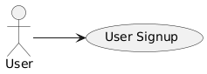

* **Description:** A new user signs up with their details and receives an email verification link.
* **Actor**: User
* **Basic Flow:**

1. User fills signup form with name, email, password.
2. System registers the user.
3. User details are save in the db and user is redirected to login page.

## Use Case 2: User Login

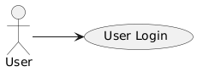

* **Description:** A verified user logs into the platform.
* **Actor:** User
* **Basic Flow:**

1. User submits email and password in login form.
2. System checks credentials and if user is verified.
3. If verified, system issues JWT token.
4. User login successful and is redirected to blogs page

## Use Case 3: View Blog Posts

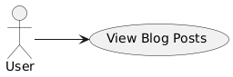

* **Description:** A user views the list of available blog posts.
* **Actor:** User
* **Basic Flow:**

1. User accesses blogs page.
2. System displays blog posts.
3. User clicks a post to open full content in popup.

## Use Case 4: Admin Manage Blog Posts

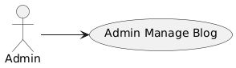

* **Description:** An admin can create and delete blog posts.
* **Actor:** Admin
* **Basic Flow:**

1. Admin logs in.
2. Admin accesses Admin Dashboard.
3. Admin creates or deletes blog posts via interface.
4. System updates the database accordingly.

## Use Case 5: Role-Based Authorization

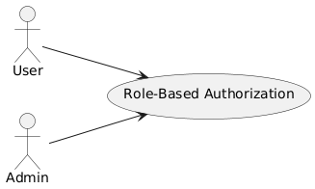

* **Description:** Control access to resources based on user role (user/admin).
* **Actor:** User, Admin
* **Basic Flow:**

1. System reads user role from JWT.
2. If user role is 'admin', allow full blog management.
3. If user role is 'user', allow only viewing blogs.
4. Unauthorized access is denied.

# Future Scope

* Add comment functionality for posts.
* Add user profile and profile picture upload.
* Add blog post categories and tags.
* Enable pagination for blog listing.